Product information
Product number： | M20-T41004B - 24W
Track System: | 4 wire
Input Voltage (v): | 48V DC
Dimming: | On/Off，1-10V，DALI
Light source: | SMD LED
luminaire Lifetime： | 30.000h（L80, Ta25°C）
IP Rating: | 20
Working Temperature (°C) | -5 ~ +30
Shell Material: | Aluminium
Fitting Colors: | Sandy Black / Sandy White
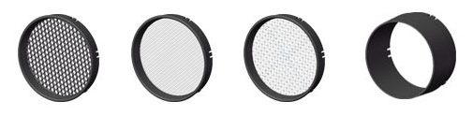
Honeycomb Oval diffuser Diffuser Anti-glare ring
L01 L02 L03 L04
Packaging information
N.W. lamp (Kg)： | 0.26
G.W. Carton (Kg)： | N/A
Master carton dimensions(mm)： | 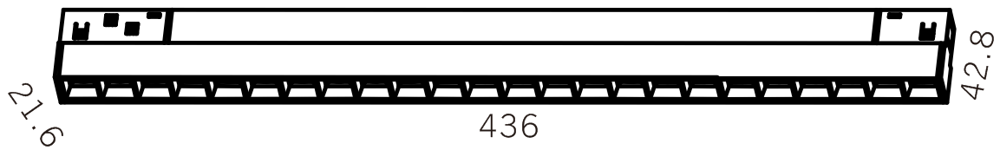  N/A
Quantity per carton(PCS)： | N/A

Beam | Watt | CRI | Luminous | CCT | Code
24 | 24W | 90 | 1839 lm | 4000K | M20-T41004B-LNS24G40-24
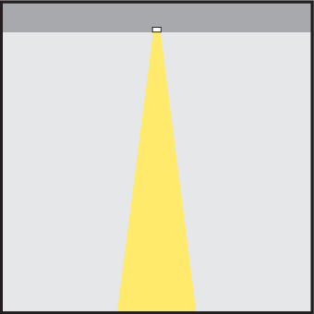 |  |  | 1750 lm | 3000K | M20-T41004B-LNS24G30-24

- ② ③ ④ ⑤ ⑥ ⑦ ⑧ ⑨
Code composition：M20 T410 - 04B - LN S 24 G30 - 24 - B
① Product series | ② Model | ③ Track & length | ④ Dimming type style | ⑤LED type | ⑥ Watt | ⑦ LED Kelvin & CRI |  |  | ⑧ Optical angle | ⑨ Finishes
M20 | T410 | 04B 436*21.6*42.8mm | LN No dimming | S SMD | 24W | G30 | 3000 | >90 | 24D | Black
 |  |  | LV 0-10V dimming |  |  | G40 | 4000 | >90 |  | White
 |  |  | LD DALI Dimming

